|  |  |  |  |
| --- | --- | --- | --- |
| Description: pact jpg1 | **Mathematics Essential**  **Test 9, 2015**  **Topics – Statistics** | | 47  = % |
| **Total Time:** | ***45*** *minutes* |  | |
| **Total Reading:** | *5**minutes* |
| **Total Working:** | *25**minutes* |
| **Weighting:** | *4 of the year.* |
| **Equipment Allowed:** | *Calculator* |
| ***You must include all working out to receive full marks*** | | | |
| **CALCULATOR ASSUMED** | | | |

1. **(6 marks:1, 1, 1, 1, 1, 1.)**

Using the following words complete the sentences below:

***Mean Median Mode Range Outlier Quartile Percentile Standard Deviation***

a.______________________________ is a measure of spread that describes how far scores are from the mean.

b. The ________________ is the most common or frequent score.

c. An _________________ is a score that is very different from the rest of the data. It can be either much bigger or much smaller than the other scores.

d. The ________________________ is the middle score when the scores are placed in order from smallest to largest.

e. The ____________________ describes the spread of data.

f. The ________________________ is calculated by adding all the scores and diving by the number of scores. It is what most people call the ‘average’.

1. **(10 marks: 5, 5)**

Calculate the mean, median, mode and range of the following:

1. Height in cm; 162, 165, 150, 148, 188, 183, 166, 164, 172.

Mean______________________________________________

Median____________________________________________

Mode______________________________________________

Range_____________________________________________

1. Cars per household; 1, 1, 2, 3, 5, 0, 0, 2, 2, 1, 2.

Mean______________________________________________

Median____________________________________________

Mode______________________________________________

Range_____________________________________________

1. **(8 marks:1, 1, 1, 1, 1, 3)**

The following stem and leaf plot shows the price of petrol (in cents per litre) at a random selection of metropolitan petrol stations on a Friday.

|  |  |
| --- | --- |
| 14 | 3 9 9 |
| 15 | 1 2 2 3 5 |
| 16 | 5 5 5 9 9 |
| 17 | 2 3 5 |

1. How many petrol stations were in the sample?
2. What is the highest price for petrol?
3. What is the spread of the prices for petrol?
4. What is the median price of petrol?
5. Is there a mode? If so, what is the mode price of petrol?
6. Calculate the mean price of petrol?

1. **(10 marks: 6, 4)**

The following boxplot shows test results for a class:

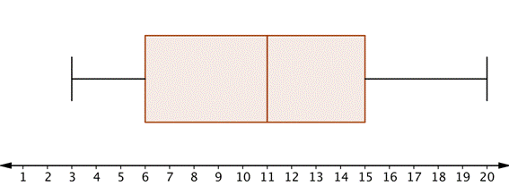

State whether the following questions are true or false:

1. The range of the data is 15__________________________________________
2. The interquartile range is 9_________________________________________
3. About 50% of the scores lie between 6 and 15__________________________
4. Fifty percent of the scores are less than 10_____________________________
5. About seventy five percent of the scores are greater than 11______________
6. About twenty five percent of the scores are greater than 15_______________

There were 30 students who sat the test.

1. What was the highest mark?_________________________________________
2. What was the lowest mark?__________________________________________
3. Approximately how many students score less than 11 out of 20?____________
4. Estimate the number of students who scored 13 out of 20._________________
5. **(5 marks)**

Using the following information construct a boxplot

Lowest score = 5, highest score = 19, median = 10, Q1=8, Q3=15

1. **(8 marks)**

Draw a box and whisker plot for the following data set:

5, 1, 7, 8, 3, 6, 3, 6, 8, 4